TA202 PROJECT

FOURBAR LINKAGE GRIPPER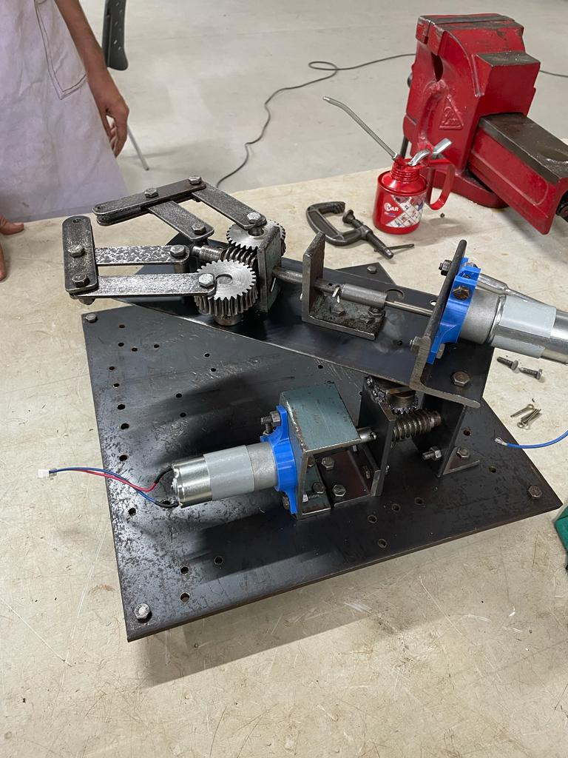

PROJECT GROUP : **50**

INSTRUCTOR : **Prof. Arvind Kumar**

TUTOR : **Dr. Avinish Tiwari**

PROJECT GUIDE : **Mr. Rakesh Thapliyal**

**Acknowledgement**

We sincerely thank our tutor, Dr. Avinish Tiwari, and our TA202 laboratory guide, Mr. Rakesh Thapliyal, for their invaluable assistance and advice on this project. We could not have completed this difficult task without their moral and technical support.

We would like to thank all lab staff and our guide, Mr. Rakesh Thapliyal, for their constant supervision and encouragement, which assisted us in completing this project.

**Abstract**

A piece of end-of-arm tooling called a gripper is used in robots to grasp, hold, lift, move, and control the materials they are working with. Handling materials has traditionally been done with the hands of humans because it is the most common, versatile, efficient, and delicate method. However, in order to effectively replace human hands in situations involving repetitive motions, substantial loads, and harsh environments, grippers had to be invented. The purpose of this project is to develop a four-bar linkage claw gripper that can manually grasp items without the aid of any form of electrical power.

**Introduction**

Our machine works on the principles of conversion of rotational motion to translatory motion. A worm gear is connected to a motor that rotates about its principal axis. 2 gears are linked to this worm gear. 2 links are then respectively attached to one of the gears which rotate freely with the gear. Further 2 links containing grippers at their ends are connected to these links through a nut and bolt. A gripper is end-of-arm tooling used in a robot for grasping, holding, lifting, moving, and controlling of materials. Another motor is also used to rotate the linkage gripper along with the plate.

Human hands have been the most common, versatile, effective, and delicate form of material handling. But, for repetitive cycles, heavy loads, and under extreme environments, grippers had to be developed as a substitute for human hands.

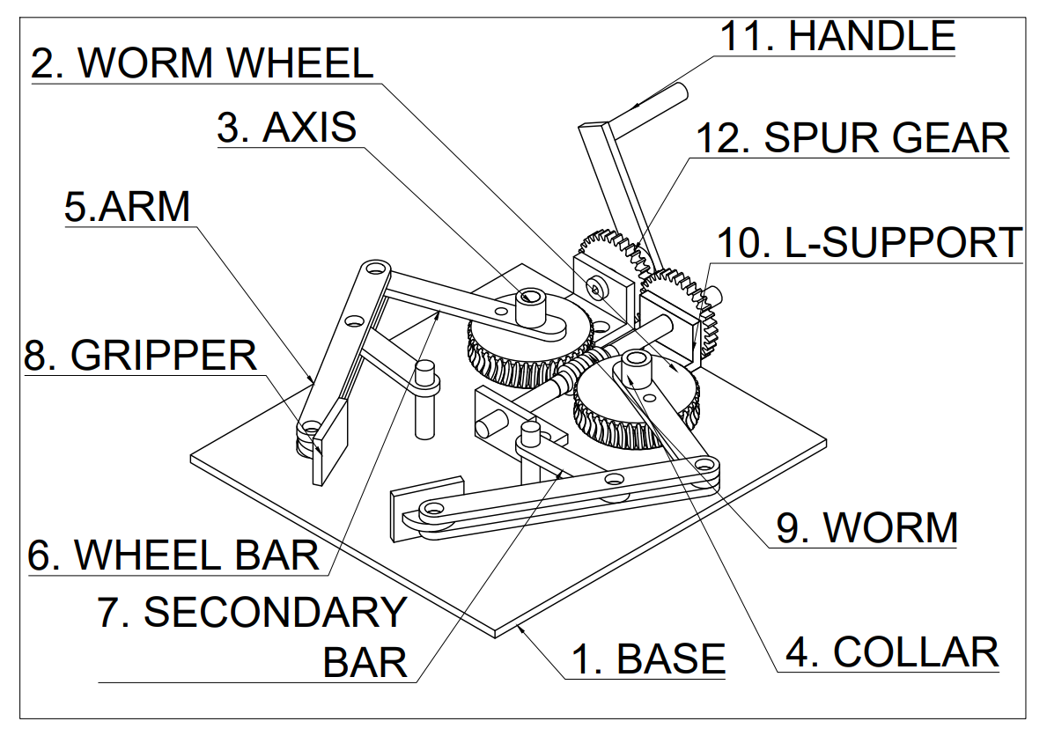

**INDEX**

|  |  |  |  |  |  |  |  |  |
| --- | --- | --- | --- | --- | --- | --- | --- | --- |
| Part No. | Part Name | Dimension(mm) | Page No. | Quantity | Material  Used | Process | Mass (kg) | Total Mass (kg) |
|  | Isometric  View |  | A1-A3 | 1 | Mild Steel |  |  |  |
| 01 | Base | 300x300x5 | 1 | 1 | Mild Steel | Conventional | 3.5325 | 3.5325 |
| 02 | Wheel | D=63.91  t=17.5di | 2 | 2 | Mild Steel | Conventional | 0.4407 | 1.8814 |
| 03 | Axis | 85x10 | 3 | 4 | Mild Steel | Conventional | 0.0062 | 0.0247 |
| 04 | Collar | D=14, d=7.5, H=11.35 |  | 4 | Mild Steel | Conventional | 0.0098 | 0.0391 |
| 05 | Arm | 150x10 | 4 | 4 | Mild Steel | Conventional | 0.0589 | 0.2355 |
| 06 | Wheel Bar | 104x5, R=8  d=7.5 | 5 | 2 | Mild Steel | Conventional | 0.0653 | 0.1306 |
| 07 | Secondary Bar | 81x5, R=8  d=7.5 | 6 | 2 | Mild Steel | Conventional | 0.0509 | 0.1017 |
| 08 | Gripper | 50x30  Dia=10 | 7 | 2 | PLA/ABS | Conventional |  |  |
| 09 | Worm | 50.98x10.98 | 8 | 1 | Mild Steel | Conventional | 0.0379 | 0.0379 |
| 10 | L-Support |  | 9 | 8 | Mild Steel | Conventional |  |  |
| 11 | Horizontal Bar | d=9.5, D=14, H=65 | 10 | 1 | Mild Steel | Conventional |  |  |
| 12 | Vertical Bar | 78.3x40x3 | 11 | 2 | Mild Steel | Conventional |  |  |
| 13 | L support  Type 2 | 30x30x6 | 12 | 2 | Mild Steel | Conventional |  |  |

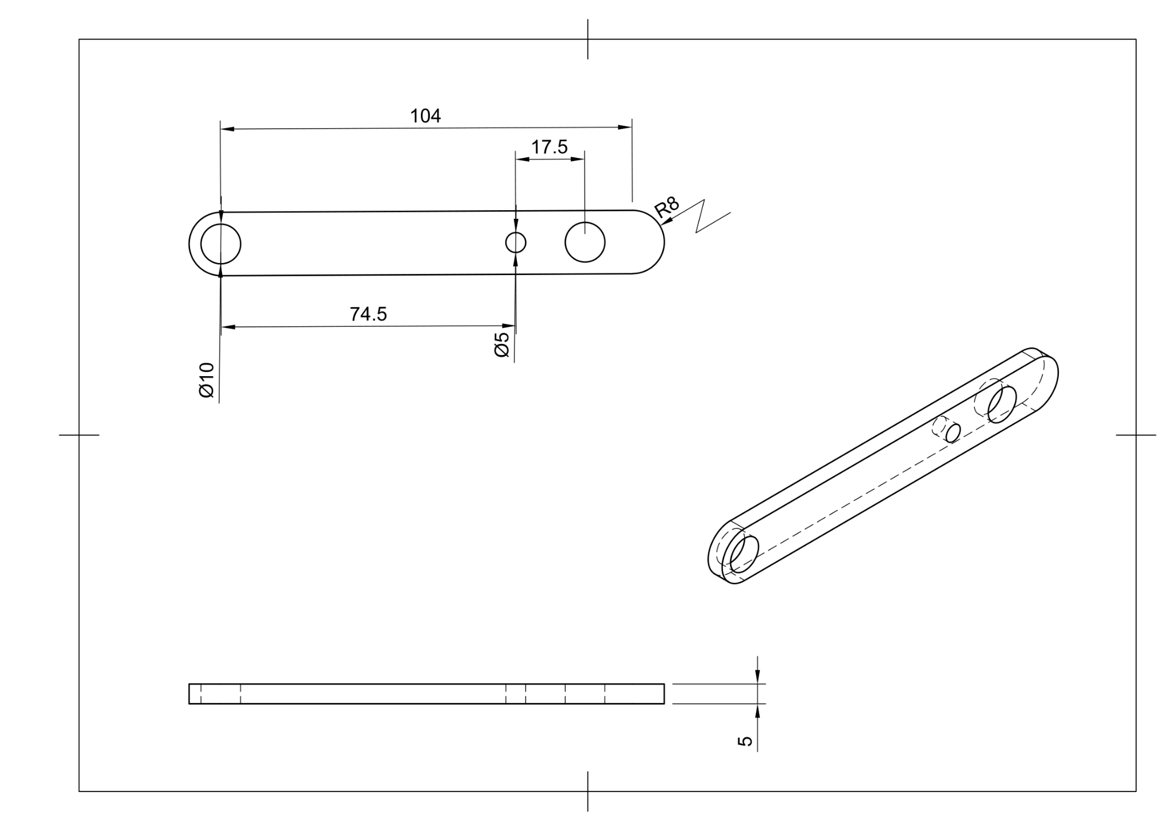

# **Weakness**

## Only one degree of movement of Gripper.

## Manually controlled.

# **Improvements**

## Can improve the device by adding movement in pitch and x direction.

## Integrate high power motor and sensors in the slot created so that it would run without any manual intervention.

## Can wrap a material around the gripper with a high coefficient of friction.

**COST ANALYSIS**

* **Material Cost**

|  |  |  |  |
| --- | --- | --- | --- |
| **Parts** | **Qty** | **Material** | **Total Mass(kg)** |
| Base | 1 | Mild Steel | 3.5325 |
| Wheel | 2 | Mild Steel | 1.8814 |
| Axis | 4 | Mild Steel | 0.0247 |
| Collar | 4 | Mild Steel | 0.0391 |
| Arm | 4 | Mild Steel | 0.2355 |
| Wheel Bar | 2 | Mild Steel | 0.1306 |
| Secondary Bar | 2 | Mild Steel | 0.1017 |
| Worm | 1 | Mild Steel | 0.0379 |
| **Total** | **20** |  | 7.5322 |

**Total Cost = 7.5322 x 90**

**= 677.898**

* **Machining Cost**

|  |  |  |  |
| --- | --- | --- | --- |
| 1. | **Lathe** | 1 x 350 | Rs 350 |
| 2. | **Milling** | 0.5 x 450 | Rs 225 |
| 3. | **Drilling** | 1.5 x 100 | Rs 150 |
| 4. | **Cutting** | 0.33 x 60 | Rs 19.8 |
| 5. | **3D Printing** | 1.5 x 300 | Rs 450 |
|  | **TOTAL** |  | **Rs 1194.8** |

* **Labour Cost**

Skilled Labour = 5.5(hrs) x 850/8 = Rs 584.375

Unskilled Labour = 7(hrs) x 650/8 = Rs 568.75

**Total = Rs 1153.125**

**Entire Cost = Rs 3025.823**